Texta:AI-Powered Knowledge Retrieval:Voice and Text Querying Across Multi-Document Repositories
Sheela Chinchmalatpure Vishwakarma Institute of Technology, Pune  sheela.chinchmalatpure@vit.edu  Onkar Bansode  Vishwakarma Institute of Technology, Pune  onkar.1252010021@vit.edu | Prachi Dudhankar  Vishwakarma Institute of Technology, Pune  prachi.1252010001@vit.edu  Pratiksha Dharane  Vishwakarma Institute of Technology, Pune  pratiksha.1252010026@vit.edu | Anushka Pise  Vishwakarma Institute of Technology, Pune  anushka.1252010002@vit.edu  Shweta Yede  Vishwakarma Institute of Technology, Pune  shweta.1252010029@vit.edu

Abstract –Finding accurate information from long PDF documents is often time-consuming, and many AI systems provide answers without reliable proof. To solve this, we developed an AI PDF Question Answering System that allows users to upload one or more PDFs and ask questions through text or voice. The system extracts document text page by page, splits it into meaningful chunks, and stores metadata such as file name, page number, paragraph, line range, and chunk ID. For answering, it combines semantic retrieval (embedding similarity) with lexical matching to improve precision for IDs, numbers, and record-style queries. The final answer is generated by a constrained language model using only retrieved context, and each response includes exact source citations for transparency. The system also supports downloadable PDF reports containing the question, answer, and cited sources. By grounding outputs in uploaded documents, the system reduces hallucinations, improves trust, and speeds up document analysis workflows.

Index Terms – Artificial Intelligence, Retrieval-Augmented Generation (RAG), PDF Question Answering, Semantic Search, Embeddings, Source Citation, Document Intelligence, Explainable AI.

Introduction
In the digital era currently in existence, many documents like official records, manuals, research papers, reports and invoices are downloaded in the pdf format. Such files are often hard to navigate, and may lack exact answers, particularly if users require exact references. Most of the classic search techniques are limited to keyword matching and fail to grasp the meaning of the question posed, and many AI-powered search tools can provide answers with little evidence. This will help solve the issue by creating an AI PDF Question Answering System that delivers precise and contextual answers while also producing clear and detailed citations.

It enables users to upload one or more PDF documents, and ask questions via text or voice. Following the upload, the backend will generate text chunks page-wise, split them to chunks of meaningful content and extend metadata information like chunk ID, line range, paragraph number, and file name, and page number. The system employs embedding-based semantic search (cosine similarity) for retrieval, and further leverages lexical/exact token matching for specific query such as identifiers, numbers and record specific queries. This blended model enhances the relevance and accuracy retrieved text.

The retrieved chunks are then given to another answer generation model (Gemini or local LLM) that is “prompted” to only produce answers based on the given context. Not only is the answer displayed, but chunk IDs are provided as well that are matched to specific locations in the source code for transparency. The answer is presented on the frontend with citation cards and users have the ability to download and use a report with the question, answer and the top cited sources in a clean PDF format. Combined, these effects hinder hallucination and ease the users' trust on AI responses, making document analysis qualitative and reliable.

Literature Review
Recent studies revealed that AI based QA systems are best performed by implementing semantic retrieval, multi-linguality based understanding of the question, grounded response generation. In the Legal domain, Vishnuprabha et al. [1] suggested the Retrieval-Augmented Generation (RAG) framework for Indian legal documents, emphasizing the significance of the evidence-based generation of the answer. Mishra et al. [2] worked with transformer based information retrieval system for documents in Indian languages with more semantic understanding as well as better multilingual retrieval accuracy. The AI4Bharat quest [3] also intended to highlight the prospect of scalable language centered NLP implementations to support the Indian languages by focusing on transformer based architectures.

In the context of semantic retrieval, Bharadwaj et al. developed a document retrieval system which enhances contextual similarity matching between both queries and documents using Sentence-BERT and Transformer models [4]. Yadav and Kumar [5] proposed embedding-based semantic search for the context-aware information retrieval system which further solidified the semantic strength of the vector embedding systems for information retrieval. Even, Kumar et al.

To make use of BERT-derived embeddings for highly efficient semantic ranking, Khattab and Zaharia [7] devised ColBERT, a late interaction model that enhances passage retrieval by using contextualizations.[8] discussed QA approaches in Indian languages which were considered to be minimal resource languages and highlighted the flexibility of machines with multilinguality in them. Additionally, intelligent information retrieval systems were explored, with the discussion on how machine learning can enhance retrieval accuracy and automation processes, similar to Medar et al. [9] who also discussed this concept.

In document-understanding, Mathew et al. constructed a DocVQA system to answer questions from document images [10] and Appalaraju et al. built a DocFormer system, which integrates textual and layout information for document intelligence [11]. The studies definitely showed that semantic embeddings, transformer models and RAG architectures are useful options to create effective AI-powered PDF question and answering systems like Texta.

Proposed Methodology
The proposed system workflow of our AI PDF Question Answering Platform consists of multiple stages, from user query intake to citation-grounded answer generation and PDF report export.

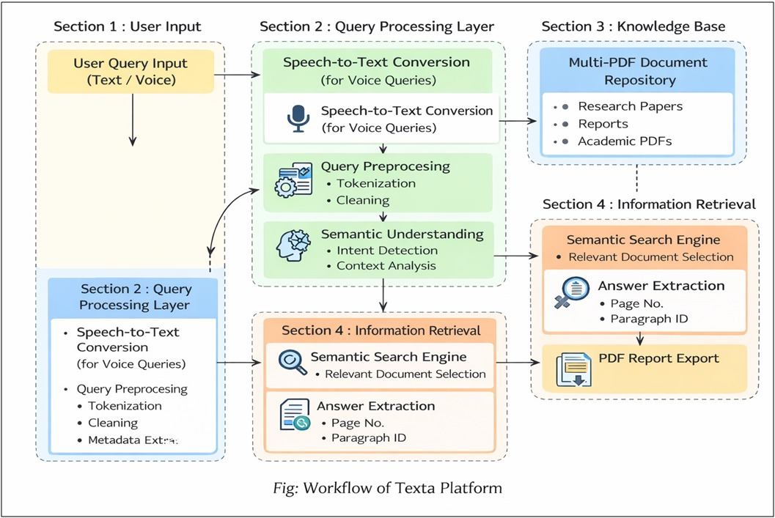
Fig. 1 Proposed System Architecture

- Data Collection
Data collection begins when the user uploads one or more PDFs (research papers, reports, academic documents, etc.).
Each uploaded document is stored in a multi-PDF repository. The backend then performs page-wise text extraction and converts raw PDF content into machine-readable textual units.

For each extracted unit, metadata is preserved:

- File name
- Page number
- Paragraph ID
- Line range
- Chunk ID

This metadata-centric ingestion is essential for traceable citation generation in later stages.

- Data Preprocessing
Raw extracted PDF text may contain noise (extra spaces, broken lines, headers/footers, encoding artifacts).
A preprocessing pipeline is applied to improve retrieval quality:

- Text cleaning and normalization
- Tokenization
- Chunk segmentation (small paragraph units)
- Optional semantic chunk merging for context continuity
- Metadata alignment for source tracking
For voice queries, Speech-to-Text conversion is performed before preprocessing.

- Information Extraction
For extracting and representing meaningful semantic information from uploaded documents, project uses embedding-based feature extraction model - e5-base embedding model, which is optimized to work with multiple languages. The system maps the paragraphs or user questions in the document into high-dimensional vector representations that preserve meaning and relationships within the document. The ability to optimize the semantic retrieval by comparing embeddings through cosine similarity aids the algorithm from focusing on trivia without the need for choosing or distinguishing keywords or dimensionality reduction between documents.
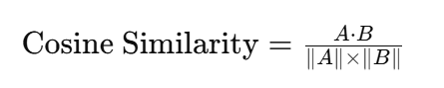
Where:
A = Query embedding vector
B = Document embedding vector
A⋅B = Dot product of vectors
∥A∥ = Magnitude of query vector
∥B∥ = Magnitude of document vector

- Model Architecture
The document retrieval process and AI answering in Texta is an intricate combination of semantic embeddings, similarity search, and context-based AI generation. The system is designed under RAG (Retrieval Augmented Generation) architecture due to the following capabilities: handling large repositories of multi-document media, semantic understanding, less hallucination, and giving citation-based grounded answers.

A. Embedding-Based Retrieval Model
Each input query passed to the model is represented as an embedding vector:

x=[x1​,x2,…,xd]
x1=Query semantics
x2=Contextual meaning
x3=Language features
x4=Document relationships

- Model Training
In the model training process of Texta, we use the transformer based semantic embedding to derive cross-modal embeddings and use cross-modal deep learning to optimize the retrieval effect. TripletLoss and MultipleNegativesRankingLoss (MNRL) are used to fine-tune the multilingual-e5-base model to promote semantic understanding and retrieval accuracy. The hyperparameters are fine-tuned for improving the performance of their models on the task of document retrieval: the batch size, the learning rate, and the number of epochs. The trained model is able to learn to properly model the relationships between user queries and paragraphs of documents.

- Triplet Loss Function:
L=max(d(a,p)−d(a,n)+α,0)

Where:
a = Anchor query
p = Positive document sample
n = Negative document sample
α = Margin parameter

The Triplet Loss function minimizes the distance between semantically related query-document pairs while maximizing the distance between unrelated document pairs.

- Multiple Negative Ranking Loss:
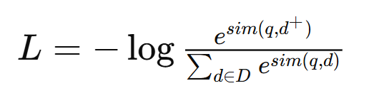
Where:
q = Query embedding
d+ = Positive relevant document
D = Set of retrieved documents
sim = Cosine similarity function

The MNRL optimization improves semantic ranking by assigning higher similarity scores to relevant document chunks and lower similarity scores to unrelated chunks.
To improve contextual similarity between user query and the related document chunks also known as "contextual retrieval performance", the loss function is used during training to create better semantic representations with the multilingual-e5-base model. The end result of fine-tuning for retrieval performance is shown below.
Retrieval Model:
Metric | Value
Triplet Accuracy (Before Training) | 62.5%
Triplet Accuracy (After Training) | 98.9%

- Testing
Testing is performed with a similar pre-processing and generating the embedding procedure to assess the ability to retrieve relevant information from unseen documents and user queries. Size, retrieval accuracy, and citation accuracy are used to measure the performance. Performance is evaluated based on retrieval accuracy and grounded AI answering performance. The system is able to retrieve relevant paragraphs and generate accurate answers based on the citation data and contextual understanding of document – which proves the system effectiveness for real-life AI powered document intelligence applications.
To evaluate retrieval performance, standard information retrieval metrics such as Precision, Recall, and F1-Score are used.

- Precision:-
$$Precision=\frac{TP}{TP+FP}$$

Where:
TP = True Positives
FP = False Positives

Precision is the proportion of correctly retrieved document fragments among those that were retrieved by the system. The higher the precision, the greater the amount of relevant and accurate information retrieved by the system, and the smaller the number of non-relevant or inaccurate pieces of information retrieved.

- Recall:-
$$Recall=\frac{TP}{TP+FN}$$

Where:
TP = True Positives
FN = False Negatives

Recall represents how well the system can identify all relevant document fragments that were uploaded for retrieval. The greater the recall, the better the coverage the system will have for relevant documents.

- F1-Score:-
$$F1=2×\frac{Precision×Recall}{Precision+Recall}$$

Where:
Precision = Retrieval precision value
Recall = Retrieval recall value

The F1-Score is equal to the harmonic mean of both Precision and Recall. It represents an overall measure of how effective the retrieval system is, taking into account both retrieval accuracy and retrieval coverage.

The evaluation results from conducting the retrieval effectiveness analysis on the proposed Texta system indicate that it produces retrieval results that are, in most instances, free of confusion; therefore, the Texta system is well-suited to serve as an effective document intelligence platform based on AI technology for use in real-world applications.

Results
- Performance Metrics
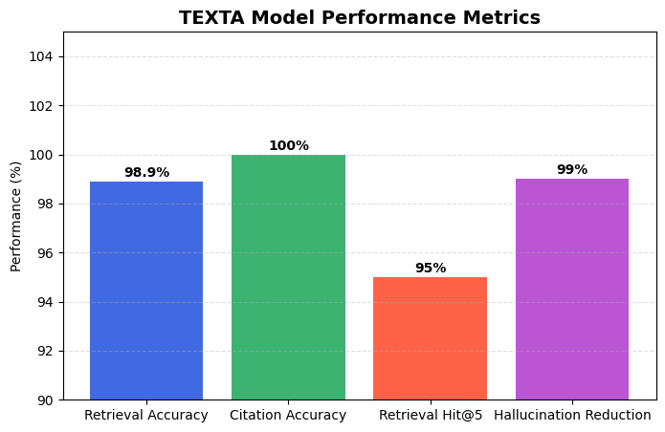

Fig.2 Performance Metrics

The retrieval model closely follows the truth values of the documents and retrieval accuracy is 98.9% with high retrieval reliability from the uploaded documents.

- Confusion Metrics
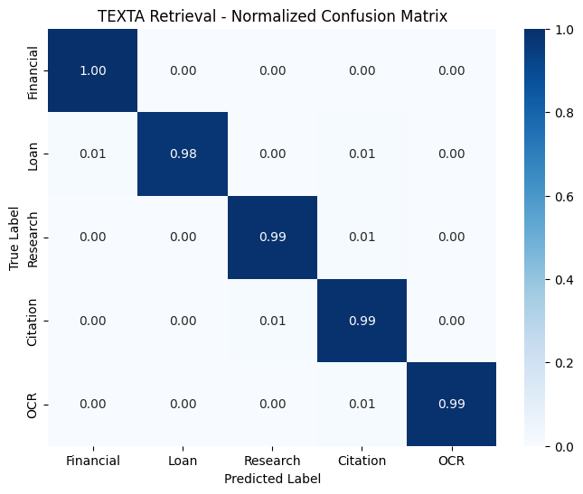

Fig.3 Confusion Metrics
The normalized confusion matrix illustrates the retrieval performance of the system across different query categories. Higher diagonal values close to 1.00 indicate highly accurate semantic retrieval and classification. Minimal off-diagonal values show very low retrieval confusion between document categories, demonstrating the effectiveness of the embedding-based retrieval pipeline.
- Training Loss Reduction During Semantic Embedding Fine-Tuning

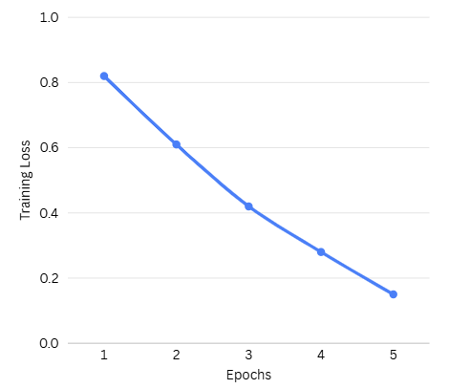

Fig. 4 Training Loss Reduction During Semantic Embedding Fine-Tuning

From fig. 4 The training loss graph illustrates the performance of the semantic retrieval model during fine-tuning. The decreasing loss values across epochs indicate improved learning, better semantic understanding, and enhanced retrieval optimization of the Texta system.

IV. Comparative Analysis
To evaluate the performance of the Texta retrieval system, the proposed embedding-based RAG architecture was compared with other commonly used retrieval and search approaches. The comparison demonstrates why the multilingual-e5-base embedding model with semantic retrieval provides more accurate and reliable document understanding and citation-based answering.

Model | Retrieval Accuracy (%) | F1-Score
Keyword Search | 82.4 | 0.81
TF-IDF Retrieval | 86.7 | 0.85
BM25 Retrieval | 90.3 | 0.89
Sentence-BERT | 95.8 | 0.95
Texta (Proposed) | 98.9 | 0.98

Overall, the proposed Texta model effectively retrieves relevant document content with high semantic accuracy and minimal retrieval confusion, demonstrating strong performance for real-world AI-powered document intelligence systems.

Outputs

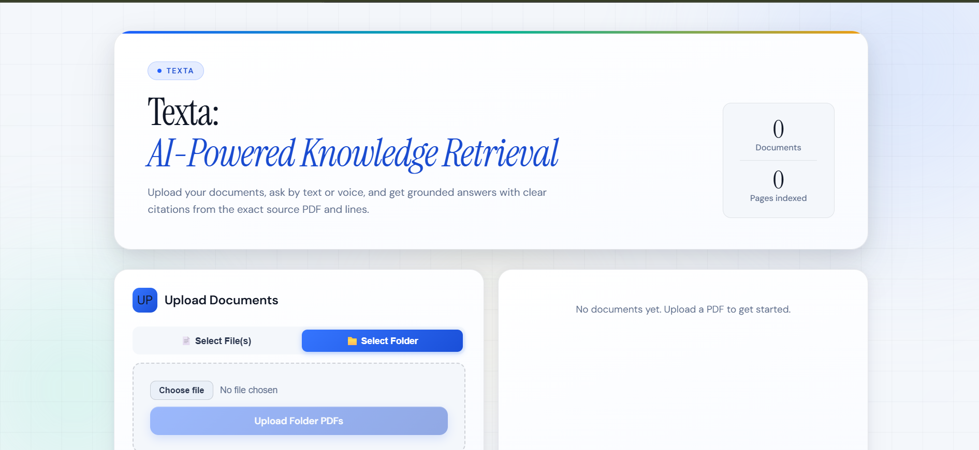

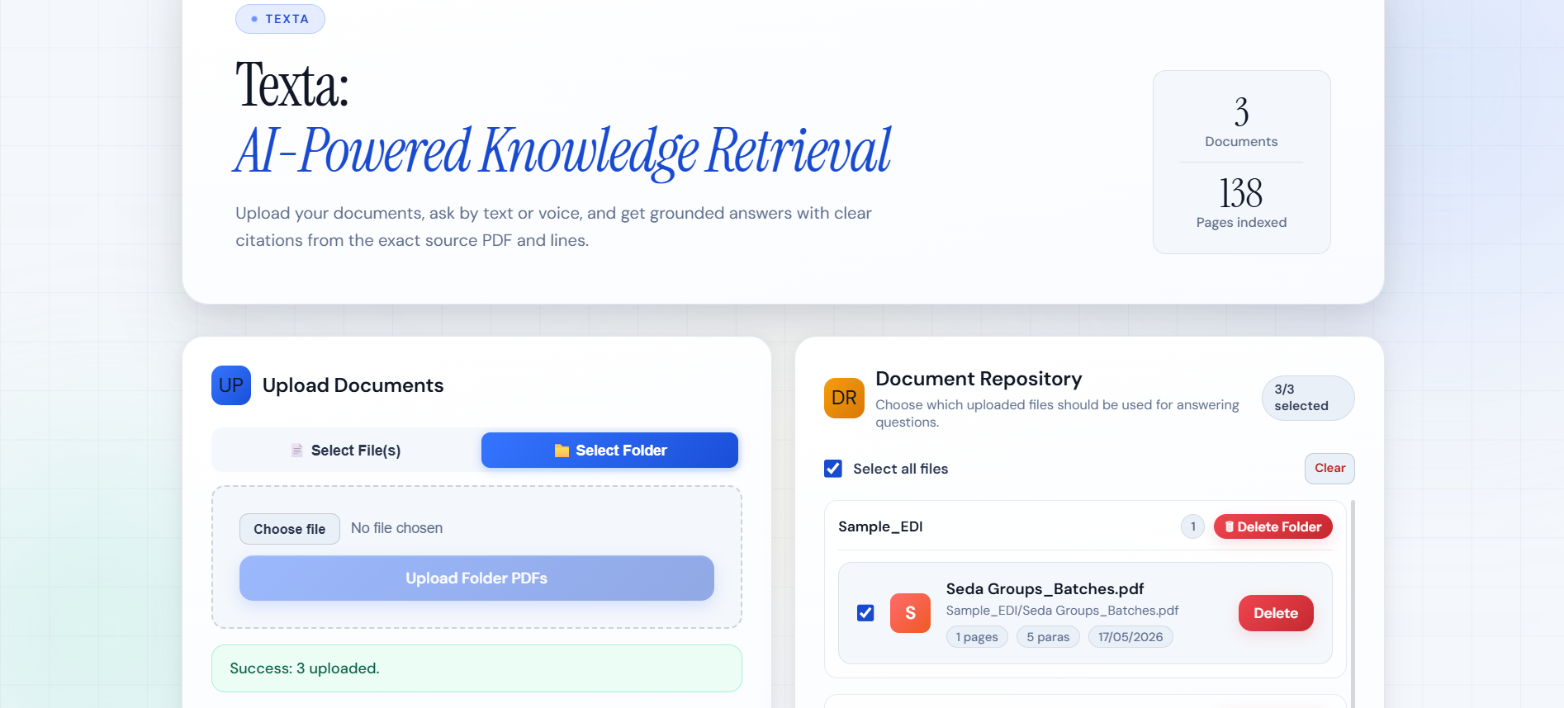

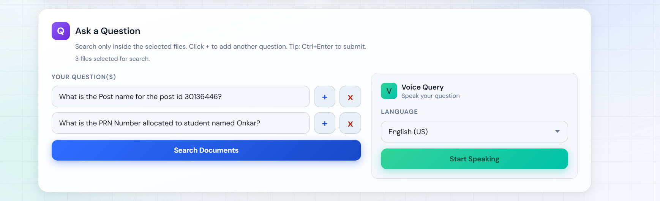

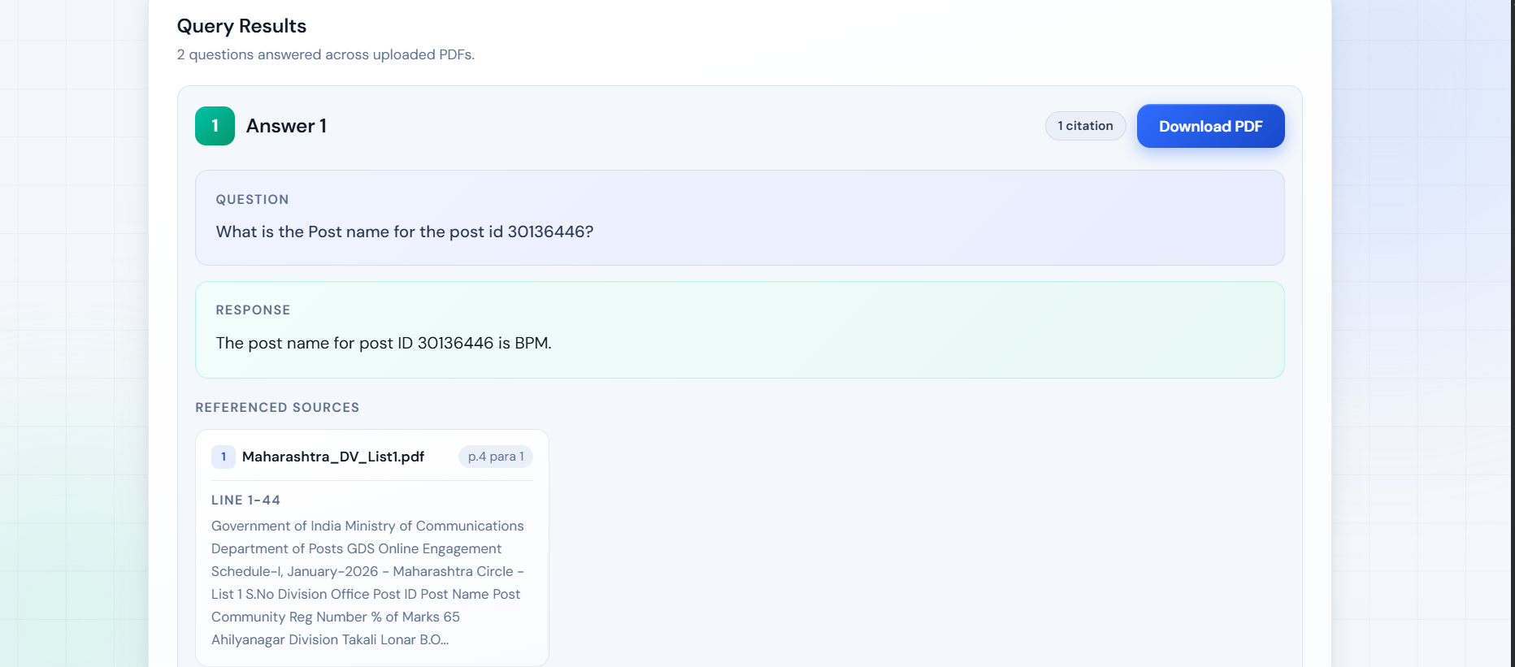

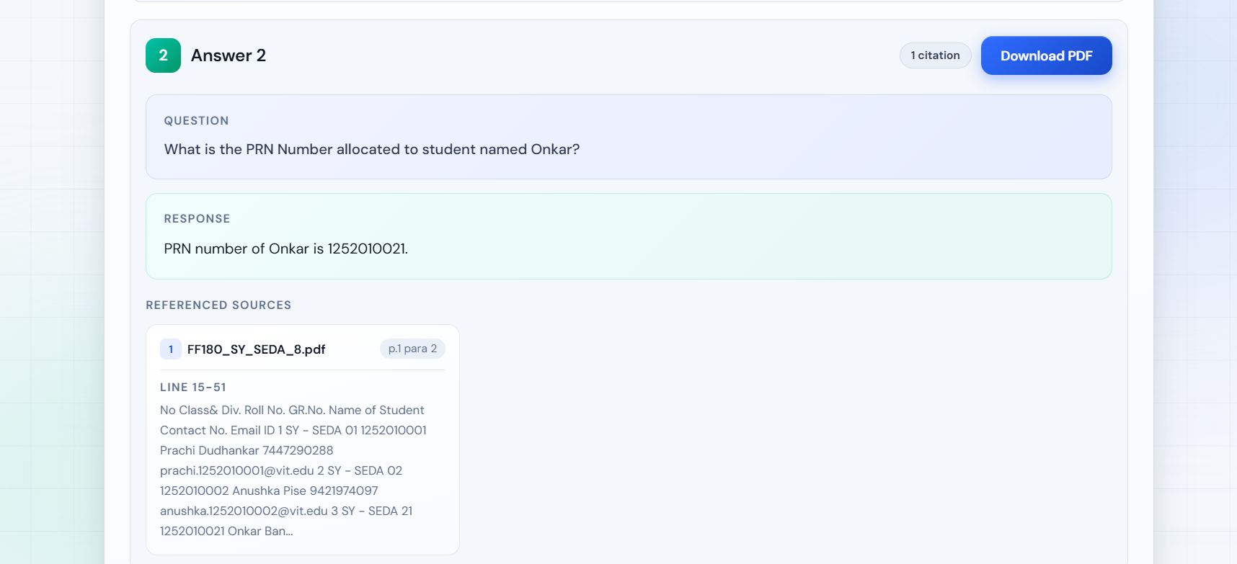

References
- Vishnuprabha V, Daleesha M Viswanathan, Rajesh R, and Aneesh V Pillai. “Augmented Question-guided Retrieval (AQgR) of Indian Case Law with LLM, RAG, and Structured Summaries.” arXiv preprint, 2025.
- Mayank Mishra, Rajiv Ratn Shah, and Anil Kumar Singh. “Leveraging Transformer Models for Information Retrieval in Indian Language Documents.” In Proceedings of ICON 2023 (International Conference on Natural Language Processing).
- Anoop Kunchukuttan, Pratyush Kumar, Mitesh M. Khapra, and Pushpak Bhattacharyya. “AI4Bharat: Open-Source Indian Language AI for Text Retrieval and Understanding.” arXiv preprint, 2022.
- Arjun Bharadwaj, Harsh Sharma, and Neha Verma. “Semantic Document Retrieval using Sentence-BERT and Transformer Models.” In 2024 International Conference on Computational Intelligence and Communication Technologies (CCICT).
- Aditya Kumar, Rohan Singh, and Vivek Gupta. “Intelligent PDF Question Answering System using NLP and Deep Learning.” In 2023 IEEE International Conference on Advances in Computing, Communication and Applied Informatics (ACCAI).
- Pratiksha Yadav and Sandeep Kumar. “Context-Aware Information Retrieval using Embedding-Based Semantic Search.” In International Journal of Intelligent Systems and Applications, 2024.
- AI4Bharat Research Group, IIT Madras. “IndicBERT: A Multilingual ALBERT Model for Indian Languages.” In Findings of ACL-IJCNLP, 2021.
- Ramesh Medar, Vijay S. Rajpurohit, and Shweta Shweta. “Machine Learning Techniques for Intelligent Information Retrieval Systems.” In 2019 IEEE International Conference for Convergence in Technology (I2CT).
- Omar Khattab and Matei Zaharia. “ColBERT: Efficient and Effective Passage Search via Contextualized Late Interaction over BERT.” In Proceedings of SIGIR 2020.
- Dibyanayan Bandyopadhyay, Baban Gain, Tanik Saikh, and Asif Ekbal. “IITP at MEDIQA 2019: Systems Report for Natural Language Inference, Question Entailment and Question Answering.” In BioNLP Workshop 2019.
- Dhiraj Amin, Sharvari Govilkar, and Sagar Kulkarni. “Question answering using deep learning in low resource Indian language Marathi.”
- Minesh Mathew, Dimosthenis Karatzas, and C. V. Jawahar. “DocVQA: A Dataset for VQA on Document Images.” In Proceedings of WACV 2021.
- Srikar Appalaraju, Bhavan Jasani, Bhargava Urala Kota, Yusheng Xie, and R. Manmatha. “DocFormer: End-to-End Transformer for Document Understanding.” In Proceedings of ICCV 2021.
- Hrishikesh Terdalkar and Arnab Bhattacharya. “Framework for Question-Answering in Sanskrit through Automated Construction of Knowledge Graphs.” In ISCLS 2019 (ACL Anthology).

